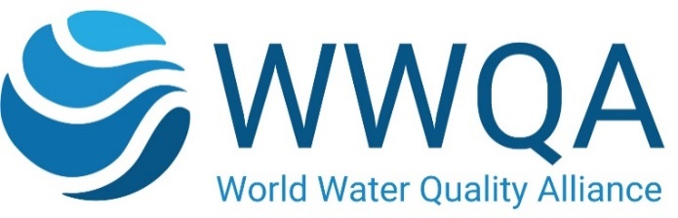

Proposal Template for WWQA Workstreams

General Information
Proposal Summary:
Within existing WWQA Work Plan and Workstream: | Please indicate the workstream in the annual work plan of the Alliance which your proposal primarily addresses. Indicate other related workstreams it relates to if applicable.  Explain how your proposal addresses the specific challenges and scope of that topic.  (Max. 200 words)
Outside the current WWQA Work Plan and existing Workstream: | If your proposal is completely new and thus yet unrelated to the existing annual agreed work plan of the Alliance please indicate if it is meant to be a stand-alone activity or if it has potential to lead into a new, broader workstream. Indicate other related workstreams it may relate to if applicable.  Explain the specific challenges and scope of that new topic.  (Max. 200 words)
Start Date:
End Date:
Proposal Title:

Proposal Rationale/Summary: | Describe and explain the overall concept, the main ideas and assumptions involved. Identify any inter-disciplinary considerations and use of stakeholder incl. civil society knowledge, as applicable. Include measures taken for public/societal engagement on issues related to the project.  Describe any other of your projects and/or activities that are linked to this project/proposal, especially where the outputs from these will feed into this project delivery;  (Max. 700 words)
Objectives: | Describe the main objectives  (Max. 500 words)
Outputs, Deliverables and Milestones: | Describe outputs and milestones in bullets  (Max.250 words)
Impacts and outcomes: | • Summarize the anticipated mid to long-term impacts and outcomes of your proposal, and its contribution to the objectives of the World Water Quality Alliance and the Assessment (as applicable)  - Explain what expected impacts and outcomes are anticipated e.g., create new opportunities; bring important benefits for water management; how your proposal incorporates and can contribute/pay attention to interlinkages and cross-cutting issues like climate change impacts, protection or restoring ecosystems, but also gender, youth, indigenous peoples, SME farmers, local communities and business etc.  (Max.500 words)
Risk factors concerning implementation: | - Describe any barriers/obstacles, such as regulations, public acceptance, financing of follow-up steps, etc., that may determine whether the expected impacts and outcomes will be achieved.  - Describe the risks concerning implementation and if possible, indicate level of likelihood: Low/Medium/High  - For each risk identified, propose risk-mitigation measures  (Max.500 words)
Regions & Countries of Operation:

Total value of the proposal in its entirety in US$ (irrespective of applying for WWQA funds or/and using existing resources):
Amount requested from WWQA seed-funds as co-financing (US$):

Project Coordinator and Partners
Principal Investigator and Partners
Legal name of the main Coordinator/Principal Investigator (PI) | The legal name of the entity signing the agreement with UNEP, preferably a not-for-profit organization, and (unless already done) must undergo UNEP’s due diligence
Acronym of the Principal Investigator (PI)
HQ country:
Type of Organization: | e.g., Not-for-Profit; NGO/ CSO; Government entity, UN Agency, etc.
Name and Title of the Representative of the partner (i.e., signatory of the agreement)
Other Partners included in the Proposal (all participating organizations, name and type of organization): | List the names of other key partners contributing to the workflow, including a brief description of their role.
Key references regarding the qualification/experience of the main coordinator and/or the partners for implementing the suggested workstream.

